Name _____________________________ Phone #__________________ Occupation__________________

Mailing Address___________________________________________________________________________

Email __________________________________________________________ Date of Birth______________

Please send me:
Email confirmations and reminders for appointments Yes No
Email newsletter/special offers (no more than 2/month) Yes No

Referred by_____________________________________ May I thank them for referring you? Yes No

The following information will be used to help plan safe and effective massage sessions. It will be kept confidential. Please answer to the best of your knowledge.

Have you had professional massage before? Yes No
How recently?

Do you have an allergies or skin sensitivities to oils or lotions? Yes No
If so, please explain

Are you wearing
contact lenses Yes No
a hearing aid Yes No

Do you sit for long hours at a workstation, computer or driving? Yes No

Do you have any particular goals for this massage session? Yes No
If yes, please explain

Are you currently taking any medications, prescription or over-the-counter? Yes No
If yes, please list

Please circle any condition below that applies to you:

Anxiety varicose veins depression high or low blood pressure

DVT/blood clots heart condition easy bruising circulatory issues
artificial joint diabetes headaches /migraines numbness

TMJ recent surgery recent injury pregnancy

osteoporosis epilepsy/seizures food allergy or sensitivity osteo or rheumatoid arthritis

Please explain any condition you circled above:

Is there anything else about your health history that you think would be useful for your massage therapist to know?

Please circle any specific areas you would like the massage therapist to concentrate on during the session:
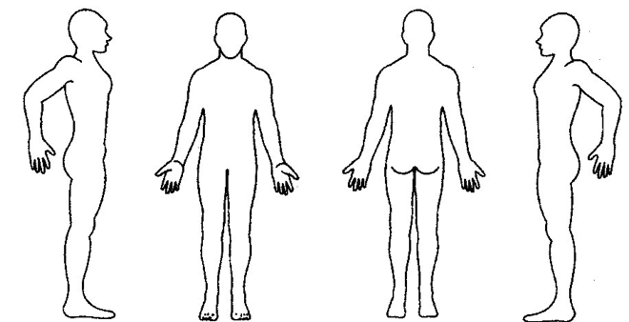

Consent for Treatment

If I experience any pain or discomfort during this session, I will immediately inform the practitioner so that the pressure and/or strokes may be adjusted to my level of comfort. I further understand that massage should not be construed as a substitute for medical examination, diagnosis, or treatment and that I should see a physician or other qualified medical specialist for any mental or physical ailment of which I am aware.

I understand that massage practitioners are not qualified to perform spinal or skeletal adjustments, diagnose, prescribe, or treat any physical or mental illness, and that nothing said during the session given should be construed as such.

Because massage should not be performed under certain medical conditions, I affirm that I have stated all my known medical conditions and answered all questions honestly. I agree to keep the practitioner updated as to any changes in my medical profile and understand that there shall be no liability on the practitioner’s part should I fail to do so.

Understanding all of this, I give my consent to receive care.

Client signature _____________________________________________ Date________________

